

**Est. 2019**

**Core Functionality:** A System for selling Travel Insurance.

**Team Members:** Lampros Karseras - Policy and Quotes

**And Roles** Georgios Karseras - Claims

Joshua Harris - Policy Holder details

Aman Gulati - Feedback & Recorded Complaints

Jeff Johnson - Staff details

**System Overview:**

*This program will sell widgets to the general public. They will have access to a web based front end allowing them to browse and filter the available stock of widgets. There will be options for the customer to place widgets into a shopping cart and create an order. Upon creation of an order there will be a requirement that they create an account where they specify their personal details along with security and payment data. There will also be facilities for them to review and modify orders.*

*In addition to a customer facing front end there will also be a staff facing back end. Once an order is created by the customer it will be added to a list of orders for processing at the back end. The back end will allow for a range of admin functions such as managing customer data, staff data, stock and running various reports on data stored in the system e.g. orders placed.*

**Erd**

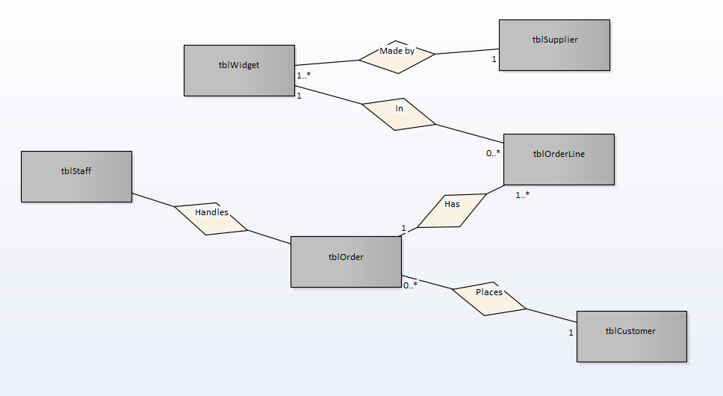

**Class diagram**

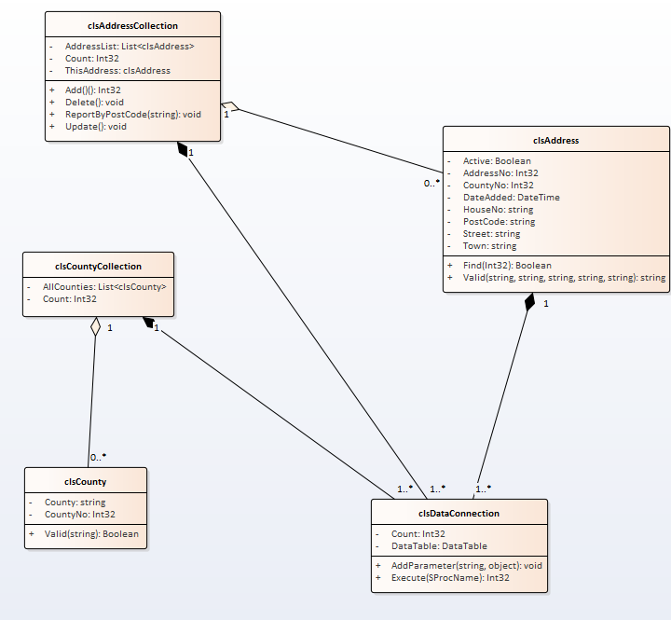

**Allocated Component:** Customer Management System

**Developer:** Jane

**Overview:**

*A customer visits the web site to buy some widgets. They have the option to add themselves as a customer to the system and edit their details. Also they are able to cancel their account on-line. Upon finding out that they are not a customer they follow the sign up process entering their details and selecting a user name and password.*

*On the back end of the system staff have the option to manage the data for all customers (add, edit delete) and run reports on customers.*

*Add -*

*Edit-*

*Update -*

*Delete -*

*List -*

*Find -*

*Filter -*

*Validate -*

**TABLE SCHEMA**

**tblWidget**

|  |  |  |  |
| --- | --- | --- | --- |
| WidgetNo | INT | Primary Key | NOT NULL |
| WidgetDescription | TEXT |  | NOT NULL |
| WidgetColour | TEXT |  | NULL |
| DateAdded | DATE |  | NOT NULL |
| Price | DECIMAL |  | NOT NULL |
| Available | BOOLEAN |  | NOT NULL |

**USE CASE DIAGRAM:**

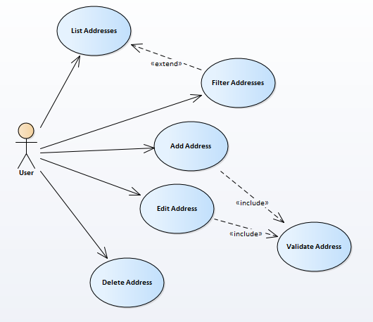

**Use case descriptions:**

**NEED ONE USE CASE DESCRIPTION FOR EACH FUCNTIONALITY DISPLAYED IN DIAGRAM. WHICH SHOULD INCLUDE AT MINIMUM:**

|  |  |  |
| --- | --- | --- |
| ***Use Case Name:*** | *Register* | |
| ***Primary Actor:*** | *Customer/ Staff – your decision* | |
| ***Business Goal:*** | *To ADD a customer on the system* | |
| ***Precondition*** | *Must be over the age of 18* | |
| ***Success Condition*** | *A customer is now registered and can buy widgets* | |
| ***Main Path*** |  | |
|  | 1. Nonregistered customer clicks ‘Register’ on the Index page | 1. System will display Register page. |
|  | 1. Customer then enters information requested into the fields and presses register button. | 1. System redirects the newly Registered customer to the Log in page. |
| ***Variant Paths*** |  | |
|  | 3a. User enters invalid data  1.System will display validations and request information to be re-entered.  3b. username already exists in the database  1.System will display message telling user they already have an account and re-direct them to login  4a. Server error   1. System displays error message and tells user to try again later | |

*Add , Edit, Update ,Delete ,List ,Find ,Filter ,Validate*